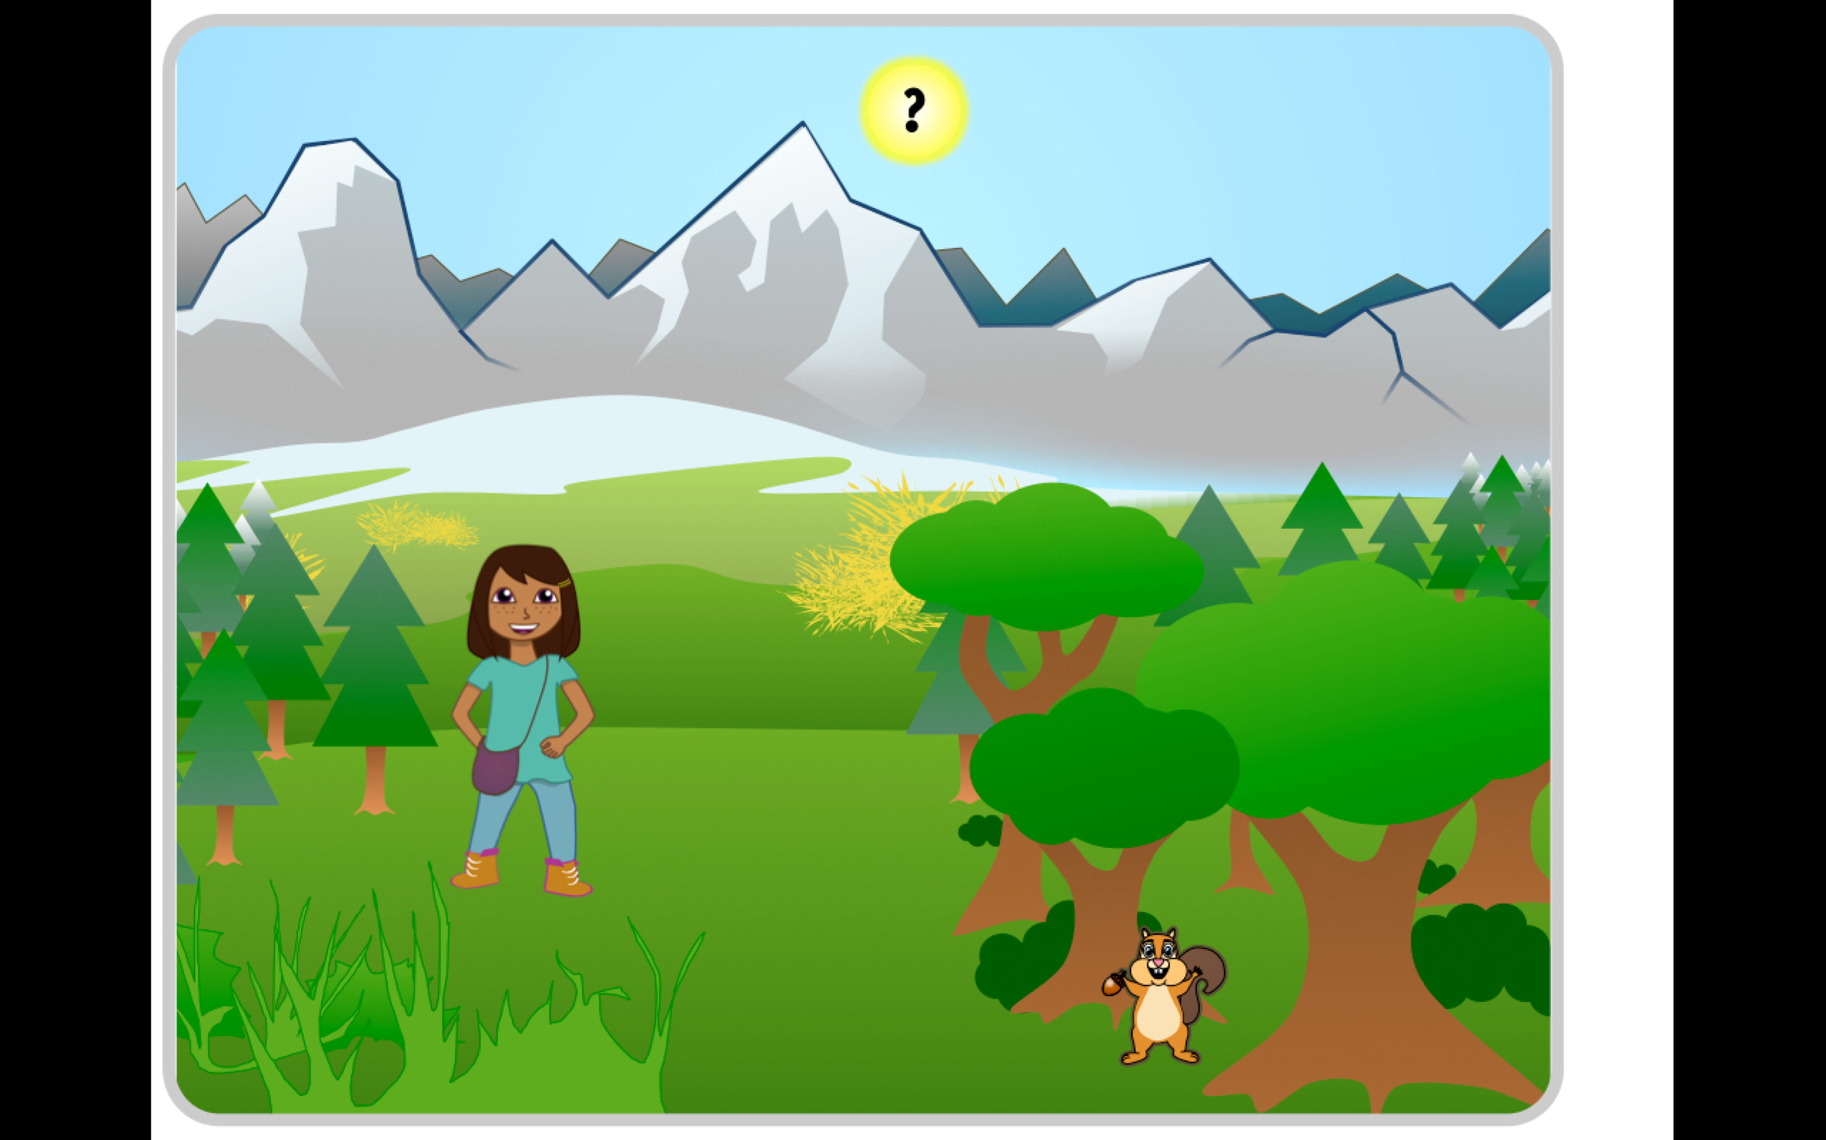

This app includes 4 view controllers, of which 1 is the initial “how to use” view controller and 1 is the “main” view controller that allows the user to select different activities. Myra, the squirrel, and the sun, each segue to another view controller. The other two view controllers are “activities” which have the most interaction with the user.

One of these view controllers will have an image with several buttons that allow the user to cycle through images of the main character, Myra. There will be at least 3 pairs of forward / back buttons. When pressed, these button change a string value of the head, body, and legs depending on the pair pressed. Thus, an initial picture named “h1b1l1.png” can be shown until one press of the head and two presses on the leg button. An automatic refresh function will update the picture to “h2b1l3.png” in this example.

The other “activity” view controller will have at least 3 math problems. This will require a simple text field which depending on the variable associated with the particular problem, will require a specific answer before allowing the user to click next and go to the next problem. Next will cycle the variables such that the required answer will change. The image cycling logic works just as above where the problems will be strings with a looped number attached “math1.png” “math2.png” etc.

